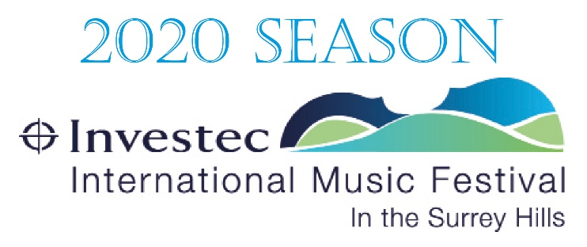

With great regret, the committee of IIMF has taken the decision today to cancel all 2020 Festival events.
We are terribly sorry to disappoint our loyal audience, but in the light of the latest measures imposed by the government and the vital need for social distancing in the efforts to limit the spread of COVID-19, we are sadly left with no other option.
All ticket holders will be entitled to a full refund on any cancelled event, and the relevant box office will be in touch with you directly to arrange this. If you feel able to treat the cost of your ticket as a donation towards the charitable activities of the Festival, we would of course be only too grateful.
If you have any queries at all, please do contact Isabel Dawson at isabel@iimf.co.uk. We are determined to regroup and focus on putting together a wonderful 2021 programme for you to look forward to next year.
Everyone at IIMF sends their best wishes, and we hope that you and your loved ones stay healthy and safe over the coming weeks.

Julia Pearson
Chairman, IIMF

